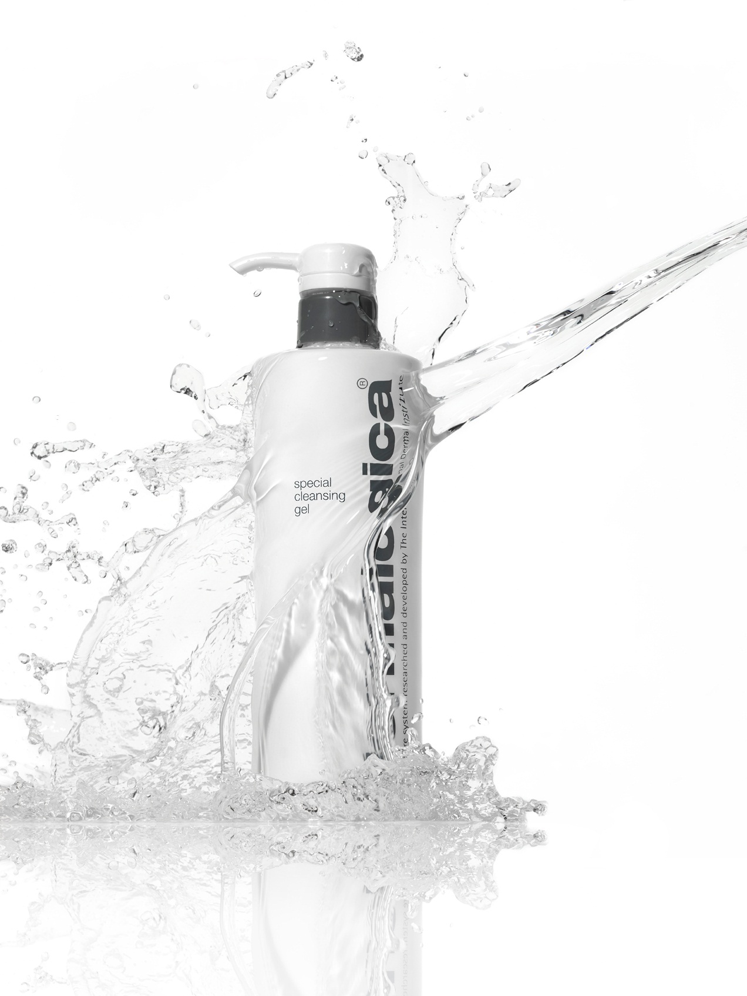
skin centre handbook template

Skin Centre Handbook

Include a contents page for easy reference and navigation

Contents

Skin Centre Culture Page 1

Skin Centre Polices Page 2
Conduct Page…
Grooming and Attire Page…
Time and Pay Page…
Family Friendly Policies Page…
Travel and Expenses Page…
Benefits Page…
Support Structure and Training Page…
Safety and Housekeeping Page…
Conduct and Disciplinary Procedures Page…

Skin Centre Procedures Page…
Morning Set-Up Page…
Evening Closures and Cash Up Page…
Treatment Room Procedures Page…
Retail & Common Area Procedure Page…
Fire Safety Page…
Client Skin Responses Page…
Greeting and Farewell Procedure Page…

Performance Criteria and Expectations Page…

Employee Agreement Page…

Skin Centre Culture
Define the Brand
Why do you do what you do?
What is your company vision or mission statement?
Points to consider include: Our People, Our Products, Our Store, Our Service, Our Standards.

Skin Centre Policies

Conduct
Based on your skin centre culture, outline your expectations for professionalism, conduct towards clients and colleagues etc.

Grooming and Attire
Acceptable hair styles and colour
Make-up expectations
Nail hygiene and standards
Acceptable jewellery
Uniform cleanliness, pressed and appropriately hemmed. Visibility of undergarments and approved footwear.
Placement of name and product badges
Acceptable seasonal / office / reception attire

Time and Pay
Salary payments, bonuses or commissions and expectations of individuals to hit set targets
Review period, and influence on annual increments or bonuses
Out of hour’s commitments for example exhibitions, training or events
Punctuality and lateness, not only arrival and departure times but lunch breaks and treatment punctuality
Holiday entitlement and restrictions
Sick pay
Notification of sickness and absence policy
Medical certificates / fitness for work / long term illness
Additional leave requests; unpaid, lieu or religious holidays

Family Friendly Policies
Maternity leave and benefits
Paternity leave and benefits
Family leave
Parental leave
Compassionate leave
Urgent dependant leave

Travel and Expenses
Expectations and entitlements when travelling to event or training venues
Skin centre purchases and petty cash

Benefits
Medical or pension schemes
Skin centre treatments
Product purchases
Ongoing training programmes
Additional incentive programmes

Support Structure and Training
Probation period, expectations at each milestone, outline that it’s a process for both parties to feel like the role is a fit.
Ongoing mentoring or review protocols
Your commitment to investing time in staff training and development
Training agreements, timelines and implications

Safety and Housekeeping
Health and safety policy including; general safety rules, fire marshal and first aider information.
Good housekeeping guidelines.
Smoking
Fragrant foods, designated eating areas and storage
Visitors or children in the workplace.
Use of skin centre equipment including PC and phones
Employee personal property
Alcohol and drug policy
Eye wash procedure

Social Media Etiquette
Preferred policies on appropriate comments, and interactions with clients.
Any expectation of individual engagement on business sites

Data Privacy Policy
Consider non-disclosure agreements regarding embargoed products, where the team receive training prior to global reveal.
Expectations in managing or sharing customer and business data or information.

Skin Centre Procedures

Morning Set-Up
Procedure for opening the skin centre. List priorities, for example turning on wax pots and listening to messages first.
Items to be addressed at the start of the day like; laundry, client cards, cleaning, lights, setting up refreshments etc.

Evening Closures and cash up
Procedure for cashing up and locking up.
Items to be addressed at the end of the day like; laundry, filing client cards, cleaning, lights, tidying up refreshments, switching electrical off

Treatment Room procedures
Stock control and usage
Trolley and bed set-up
General cleanliness and hygiene standards
Electrical equipment, safety, maintenance and cleaning
Laundry and linen
Client care procedures
Treatment times and expectations including Face Mapping® skin analysis, Skin Bar® or MicroZone®

Retail & Common Area procedure
General cleanliness and hygiene standards, including staff kitchen/room
Stock control, merchandising and shelf and product cleanliness
Face Mapping®, Skin Bar® and or ProSkin procedures
Bookings and till procedures
Customer service procedures
Fire Safety
Evacuation routes and alarm sounds or testing
Client care procedures in the event of a fire (especially if they have product on their skin)
Eye wash and emergency – portable – product removal kits
Fire Marshall

Greeting and Farewell procedure
How is a client greeted within the business? What special touches do you offer?
Thanking clients for purchases.

Client Complaints and Refund Policy
Skin centre procedure for handling complaints and record keeping
Skin centre procedure and resources for skin responses
Actioning a treatment or product refund and authorisations
Customer service provision to retain client loyalty

Conduct and disciplinary procedures
Disciplinary procedures
Problem resolution and grievance procedure

Performance Criteria for Retailer / Front Desk

brand representation

- Embodying and maintaining skin centre brand expectations
- Reflects brand guidelines in appearance and language
- Maintains reception area; free from clutter, effectively merchandised according to current promotion and is clean and hygienic.
excellent communication and networking skills
- Proactively developing professional relationships with clients; welcome each guest with a smile, can comfortably initiate and engage in conversation and actively listen to client needs.
- Assertive and clear, yet supportive conversations
- Confident networking abilities; Face Mapping® and Skin Bar®
- Communicate treatment USP’s through personal experience
- Positive confirmation calls that reinforce for clients the value of treatment resulting in confirmed attendance
proactive organisational skills
- Prioritise clients without overlooking other tasks or colleagues
- Action messages and skin centre needs
- Actively generate treatment bookings through networking conversation and personal passion
- Proactive in reaching out to clients with information on new treatments, products or events
- Maintain familiarity with business resources and treatments
- Willingness to learn and troubleshoot on one’s own before seeking help
pc literate
- Basic knowledge of MS Office packages
- Accuracy and attention to detail when utilising skin centre systems.

Performance Criteria for Professional Skin Therapists

skin therapy skills

Comprehensive Product Knowledge
- Accurately recommend and treat any skin condition
- Use and recommend products correctly and safely
- Understand the method in which product positively impacts skin condition to promote healthy skin
- Exhibit a good general knowledge of all aspects of skin and body therapy

Practical Skills
- Perform treatments and routines correctly and without aid
- Understand the purpose of techniques or massage movements
- Understand how to adapt techniques, if required, due to contraindication – including sensitisation, injury, etc

Retailing Skills
- Demonstrate key principles of HAPPY retailing
- Confidently provide lifestyle advice, regimen recommendations and treatment suggestions personalised to the client’s stated concerns and product preferences
- Contribute to business growth in services, retail and both existing client retention and new client acquisition

customer service skills

- Engage with every client, listen and meet their needs
- Be approachable, polite and respectful
- Deliver on standards and create a professional environment that builds customer loyalty
- Deal with a complaint effectively which achieves an acceptable resolution for both parties

communication skills

- Effective client interaction from arrival to departure
- Ability to clearly communicate services, retail and promotional offerings to positively impact skin centre and individual targets
- Have positive and professional interactions with line manager to discuss ongoing development, current goals and targets
- Build professional relationships with clients and team members

Performance Criteria for Lead Therapists

The Lead Therapist is expected to be an outstanding Dermalogica Skin Therapist who can perform customised treatments whilst ensuring the daily operations in their location is maintained to a high standard.
The Lead Therapist should demonstrate a thorough knowledge of the business procedure and protocol while being able to support, motivate and lead the team daily.

The skills listed below are over and above the requirements for a professional skin therapist.

coaching skills

- Have a thorough grasp of the professional skin therapist performance criteria
- Actively use performance criteria to provide an objective assessment of staff members’ performance and skill set
- Offer constructive feedback on skills and compose an individual action plan when required
- Monitor implementation of feedback and development of skills for evidence of improvement.
- Report staff progress to the line manager in respects of performance.

leadership skills

- Lead by example and be consistent in performance and conduct
- Motivate and inspire team to work towards skin centre goals
- Ability to manage day to day staff challenges professionally and objectively
- Constructively manage staff to achieve skin centre targets via recruitment; induction and mentoring

task management skills

- Prioritise workload with the needs of the customer, team and tasks in mind
- Demonstrate initiative in identifying skin centre opportunities and areas for growth
- Proactively problem solve and implement strategies that improve skin centre performance
- Able to set and monitor realistic targets for individuals, team and skin centre
- Roster team for most effective staff utilisation with customer demand in mind

Employee acknowledgement
Description of agreement reference ACAS site

Employee; full name, signature and date
Employer; full name, signature and date

Please sign and return this page to the manager or lead therapist before first probation meeting.

